HAREYA TRANSPORTATION LLC



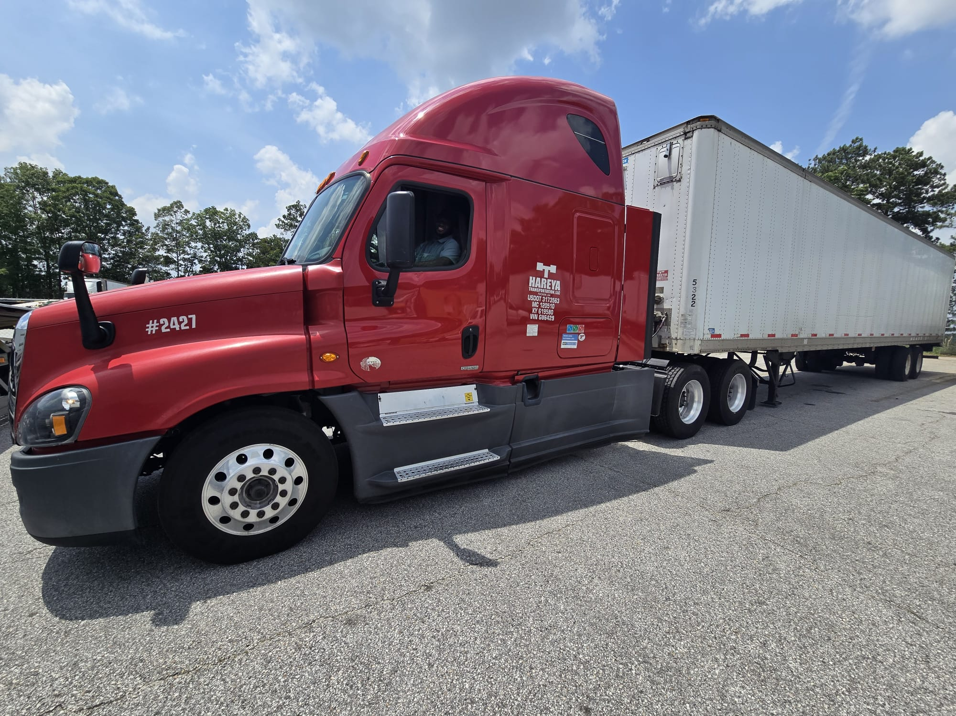**Table of Contents**

**Part I: Core Logistics Operations**

Introduction

1. Booking Loads (Plane Loads)
2. Calendar Management
3. Load Tracking
4. Dispatching Drivers
5. Payroll Settlement
6. Conclusion

**Part II: Traffic Department Operations Manual**

1. Overview of Traffic Department
2. Sending Driver Info to Brokers
3. Dispatch Confirmation
4. ETA to Shipper
5. Driver Activity Updates
6. BOL Before Departure
7. Broker Updates
8. Load Tracking & Follow-up
9. Handling Breakdowns
10. Reporting Traffic Delays
11. POD Collection
12. Final Broker Delivery Confirmation

**Part III: Financial Management & Factoring (Fleet One Guide)**

1. Introduction to Fleet One Factoring
2. Load Confirmation Retrieval
3. Broker Credit Checks
4. POD Verification
5. Building a Billing File
6. Uploading Supporting Documents
7. Completing the Process
8. Troubleshooting & FAQs

Glossary & Appendix

* Glossary of Terms
* Sample Invoice
* Sample POD & Rate Confirmation

**Part IV:Invoice Submission and Payment Coordination: A Collaborative Process with HAREYA TRANSPORTATION LLC**

1. Rate Confirmation and Data Extraction
2. Weekly Invoice Submission and Payment Processing
3. Handling Errors and Invoice Rejections
4. Monitoring Factoring Communications and Chargeback Prevention
5. Adjustments and Payment Reconciliation
6. Reserve Account Management and Chargeback Resolutions
7. Using the Wex Capital Web Portal for Document Management

PART 1

* **Introduction**  
  Established in [Year], Hareya Transportation Logistics has grown into a trusted name in freighttransport.  
  We specialize in delivering reliable, technology-enhanced logistics services, ensuring that goodsmove efficientlyfrom origin to destination. With a focus on both speed and safety, Hareya aligns its logisticssolutions withclient-specific needs, building long-term partnerships grounded in performance and trust.  
  Logistics is the circulatory system of the transportation sector, ensuring:  
  - Timely deliveries  
  - Optimized supply chains  
  - Reduced operational costs  
  Technology drives Hareya's success with real-time tracking, automation, and seamless  
  communication tools.

**CHAPTER 1**

**Booking Loads (Plane Loads)**  
Definition: Securing transportation for freight loads at an agreed rate through a broker.  
Why It Matters:  
- Key revenue activity  
- Maintains competitive positioning  
Step-by-Step Process:  
**1. Identify Available Loads**  
- Use: Load boards & broker lists  
- Criteria: Profitability & load availability  
**2. Contact Brokers**  
- Phone or Email  
- Discuss: Load details, Weight & size, Special requirements  
**3. Negotiating Rates**  
- Base rate + Additional charges (fuel, tolls)  
- Goal: Maximize profit while staying competitive

**4. Confirming the Deal**  
- Request Rate Confirmation  
- Must include: Load ID, Pick-up & delivery info, Dates  
- Store in dispatch records

**CHAPTER 2**

**Calendar Management**  
Purpose of the Calendar:  
The calendar is a central coordination tool used for organizing scheduled loads, tracking their status,  
and ensuring effective communication across the team.  
Expanded Load Entry and Calendar Workflow:  
**1. Rate Confirmation Reception**  
- After the load planning team books a load, the broker sends a rate confirmation to the company  
dispatch email.  
- The rate confirmation contains critical information for scheduling the load.  
**2. Calendar Entry from Rate Confirmation**  
- Extract the Load Number from the rate confirmation.  
- Create a calendar entry for the scheduled pick-up time and date.  
- Include in the entry:  
- Load Number  
- Pick-up Address and Time  
- Delivery Address and Date

**3. Broker Color Coding**  
- Use color codes in the calendar to differentiate between brokers.  
- This provides visual clarity and quick reference for the dispatch and operations team.  
**4. Assign Driver**  
- Once a driver is assigned to a load, add the driver's name next to the calendar entry.  
- Ensure this is done as soon as scheduling is complete.  
**5. Dispatch Status**  
- Once the load is dispatched to the assigned driver, update the calendar entry by writing  
"Dispatched".  
**6. Driver Confirmation**  
- After the driver receives and confirms the load (via email and WhatsApp group), update the  
calendar again by adding "Confirmed".  
**7. Cancellations**  
- If a load is canceled for any reason, mark it in the calendar as "Canceled".  
- Use a red color code to highlight cancellations, making them easily noticeable.  
Features:  
- Scheduled reminders for pickups and deliveries  
- Automatic updates to dispatch and drivers  
- Color-coded system for visual clarity  
- Real-time reflection of operational updates  
Sample Calendar Table:  
Date Load ID Origin Destination Driver Status  
MM/DD 12345 Chicago, IL Dallas, TX John D. Confirmed  
MM/DD 67890 Miami, FL Atlanta, GA Sarah L. Dispatched

Hareya Transportation Logistics  
MM/DD 13579 Denver, CO Phoenix, AZ - Canceled (Red)

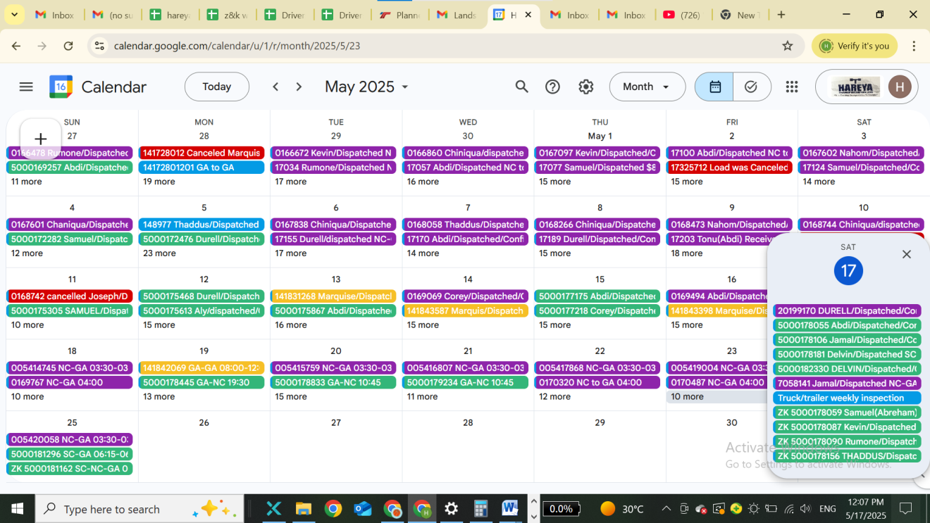

**Fig 1 Adding the scheduled Loads on Calander**

**CHAPTER 3**

**Load Tracking**  
**Overview:**  
This section focuses on how to add a trip at the trucking office, aligning scheduled loads from the  
calendar with rate confirmation details.  
Steps to Add a Trip at Trucking Office:  
**1. Plan a Load**  
- Begin by planning a load at the trucking office based on the rate confirmation.  
- Ensure that the timing aligns with what is scheduled on the calendar.  
**2. Enter Load Details**  
- Add all relevant information from the rate confirmation into the trucking office system.  
- Include:  
- Load Number  
- Broker Name  
- Pick-up Address and Date  
- Delivery Address and Date  
- Rate Amount  
**3. Add the Trip**  
- Once the load is planned and all data is entered, proceed to add the trip in the system.  
**4. Assign Driver**  
- After a driver is assigned via the calendar, update the trucking office record.  
- Add:  
- Driver's Name  
- Corresponding Load Number  
**5. Prepare for Dispatch**  
- Finalize preparations to dispatch the load with all details properly documented.

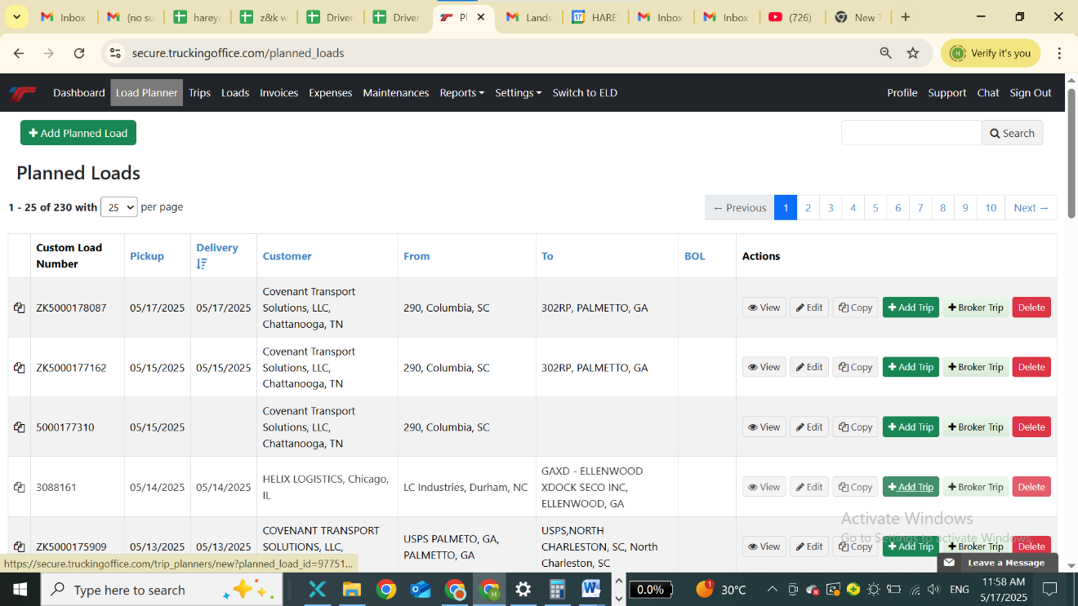

**Fig 2. Planning loads on trucking office**

CHAPTER 4

Dispatching Drivers  
Process Overview:  
The goal of dispatching is to assign the best-fit driver for each load and ensure smooth execution  
through effective communication and system updates.  
Assignment Workflow:  
**1. Evaluate Availability**  
- Check driver availability according to the calendar.  
- Consider load specifications, destination, and special requirements.  
**2. Match Drivers**  
- Select the appropriate driver based on:  
- Current location  
- Vehicle type  
- Relevant experience with similar loads  
**3. Update Calendar**  
- Add the driver's name and assignment to the calendar entry.

**4. Update Trucking Office System**  
- Once the driver is assigned in the calendar, update the trucking office software.  
- Enter:  
- Driver's full name  
- Corresponding Load Number  
- Ensure the system reflects the assignment accurately.  
**5. Dispatch Load**- Dispatch the load to the assigned driver using the trucking office system.  
- Confirm that all documents and digital instructions are sent.  
**6. Remind &confirm**  
- Remind the driver through the company WhatsApp group about the dispatch.  
- Ask the driver to confirm receipt and understanding of the load details.  
- Maintain communication for any updates or assistance during the trip.  
Effective dispatching ensures timely delivery, accurate tracking, and strong driver coordination.

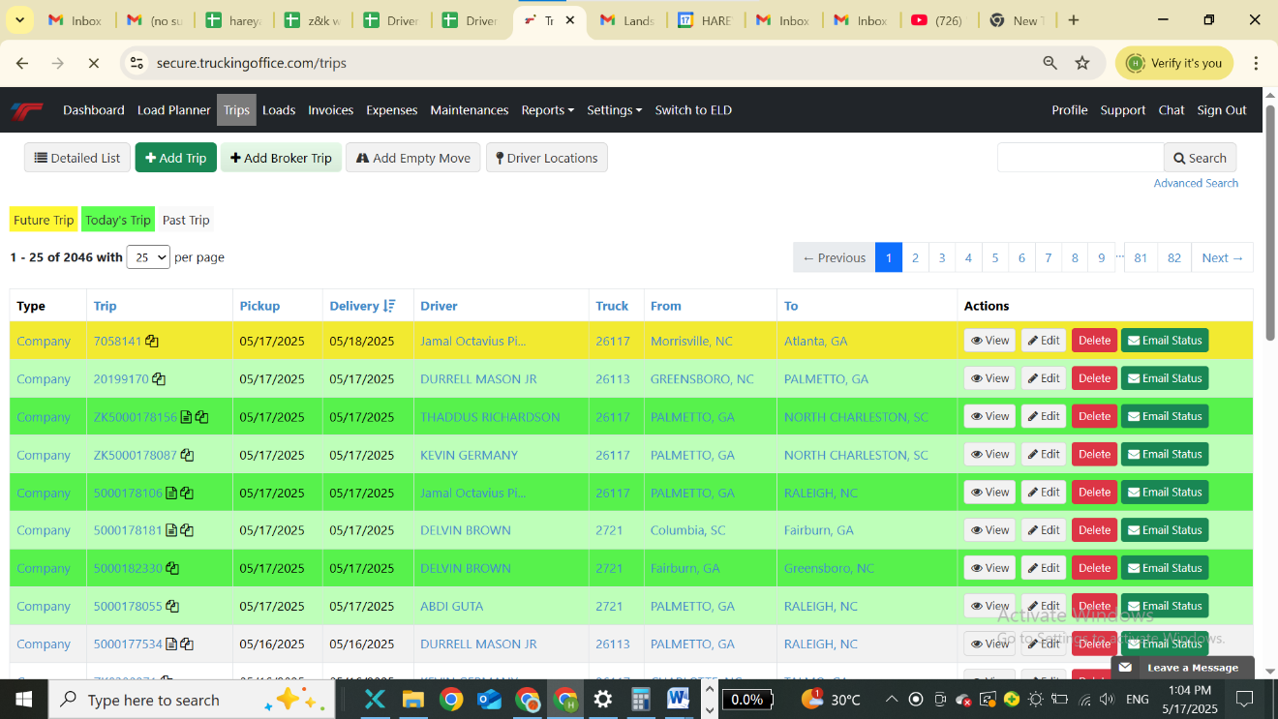

Fig 3. Dispatching Drivers

**CHAPTER 5**

Payroll Settlement  
**Overview:**  
Payroll settlement is a structured process ensuring that drivers are compensated accurately for  
completed deliveries while maintaining financial clarity for the company.  
Expanded Workflow for Payroll Settlement:  
**1. Create a Master Spreadsheet (Google Sheets)**  
- Open Google Sheets via Gmail and create a new spreadsheet titled "Driver Settlement Tracker".  
- Input essential data from each dispatched rate confirmation, including:  
- Load Number  
- Broker Name  
- Pick-up Date and Address  
- Delivery Date and Address  
- Rate Amount  
- A follow-up column: "BOL Received (Yes/No)"  
**2. Weekly Load Detail Compilation**  
- Prepare a detailed weekly report from the spreadsheet.  
- Summarize all loads completed by each driver for the week.  
- This will serve as the base for calculating gross pay and deductions.  
**3. Fuel and Expense Deductions**  
- After receiving the Fuel Settlement from fuel providers or dispatch logs, deduct fuel expenses  
per driver.  
- Record other relevant deductions, including:  
- Insurance  
- Tolls  
- Maintenance  
- Reimbursements (if applicable)  
- Update these deductions in the spreadsheet under corresponding columns.  
**4. Prepare Weekly Settlement at Trucking Office**- Use the updated spreadsheet to calculate final net pay for each driver.  
- Reflect:  
- Total Earnings  
- Total Deductions  
- Final Payable Amount  
- Double-check calculations for accuracy.  
**5. Driver and Company Payment Proportions**  
- From the weekly settlement data, compute the financial proportion between the company and  
the drivers:  
- Company Share = Total Revenue - Driver Pay - Expenses  
- Input this information in a new sheet for analysis.  
**6. Visual Analytics and Reporting**- Create charts and tables in the spreadsheet:  
- Pie Chart for Driver vs. Company Share  
- Bar Graphs comparing earnings and expenses across drivers  
- Line Charts showing trends over weeks  
- These visuals assist in:  
- Identifying performance trends  
- Forecasting profitability  
- Making informed business decisions  
**Benefits:**  
- Enhances transparency and trust with drivers  
- Provides audit-ready records  
- Helps in long-term financial planning  
Conclusion:  
An organized, spreadsheet-driven payroll system improves efficiency, ensures fair pay, and allows  
Hareya Transportation Logistics to maintain financial health while supporting its workforce.

**Conclusion**A detailed payroll system:  
- Ensures clarity  
- Builds driver trust  
- Supports company credibility  
Continuous Improvement:  
- Invest in payroll software  
- Use analytics for smarter decisions

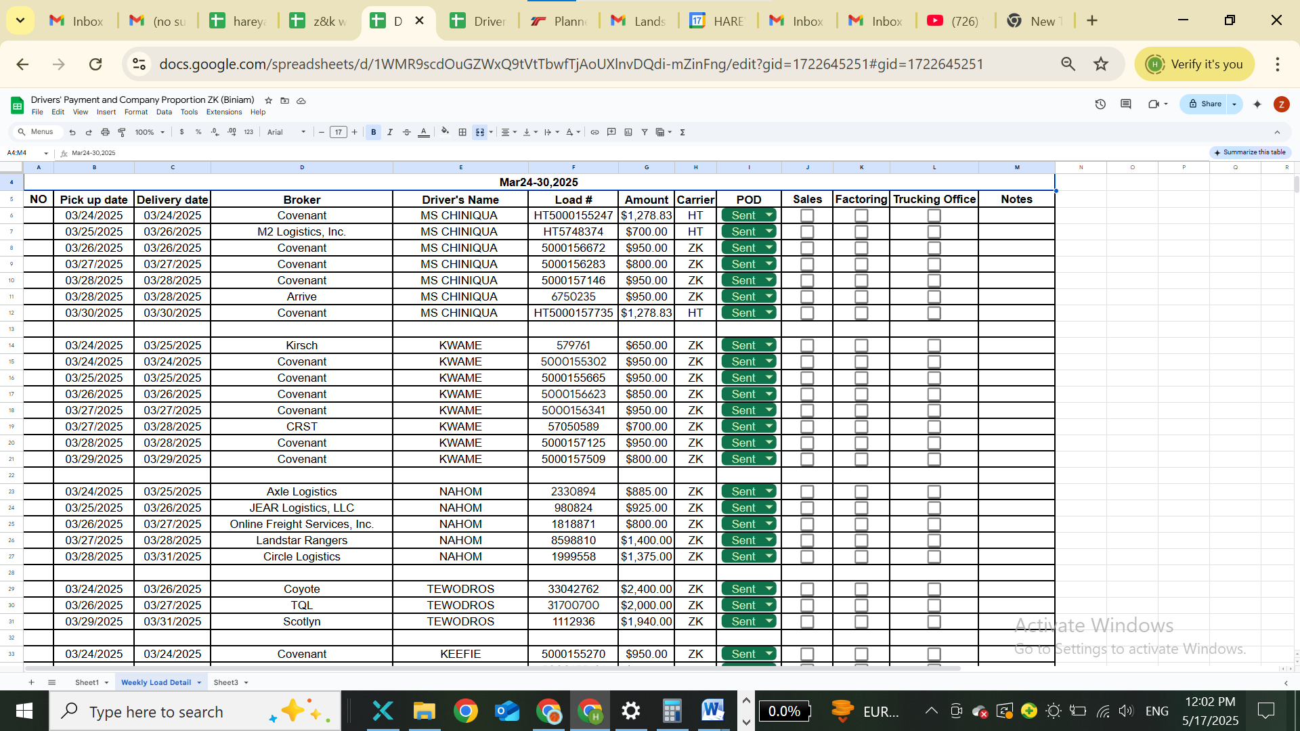

**Fig 4 Weekly Load Detail**

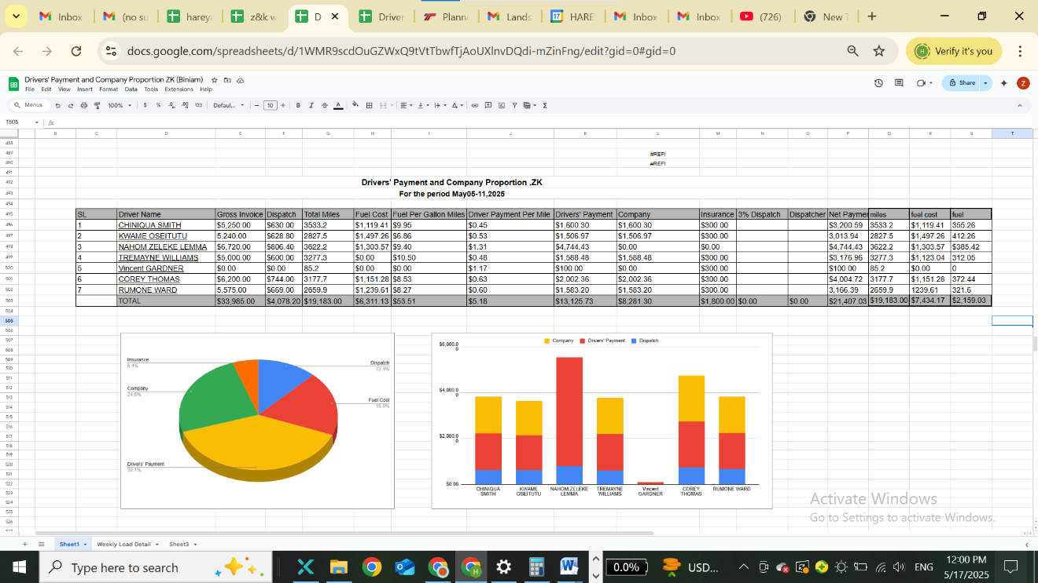

**Fig 5. Driver and company Driver Proportion**

PART 2

HAREYA TRANSPORTATION  
Traffic Department Activities Manual

# Introduction

The Traffic Department at Hareya Transportation plays a vital role in ensuring the successful coordination and execution of freight logistics. As the primary communication hub between drivers, brokers, and dispatch, the Traffic Department ensures that every load moves smoothly from pickup to delivery with real-time tracking, accurate documentation, and responsive issue resolution.

This manual outlines the standard operating procedures and responsibilities of the Traffic Department. It is designed to promote clarity, accountability, and consistency in our operations. Each section details a specific duty or workflow, from initial dispatch to delivery confirmation, helping our team maintain the high standards of service that Hareya Transportation is known for.

# 1. Sending Driver Information to Brokers

Objective:  
Ensure that brokers are informed in advance about the driver assigned to their load to build trust, reduce miscommunication, and enable efficient coordination at the pickup location.

Procedure:  
At least one day prior to the scheduled pickup date, the Traffic Department must send the following information to the appropriate broker for each load:

- Load Number (Load #)  
- Driver Full Name  
- Driver Contact Number  
- Truck Number

Communication Protocol:  
The information should be sent via email, using a clear subject line (e.g., “Driver Info for Load #12345 – Pickup 05/02”). A template may be used for consistency. In case of any driver changes after the initial communication, an immediate update must be sent to the broker with the revised driver details.

Importance:  
Proactive communication minimizes delays at the shipping point and reassures the broker that the load is being handled professionally.

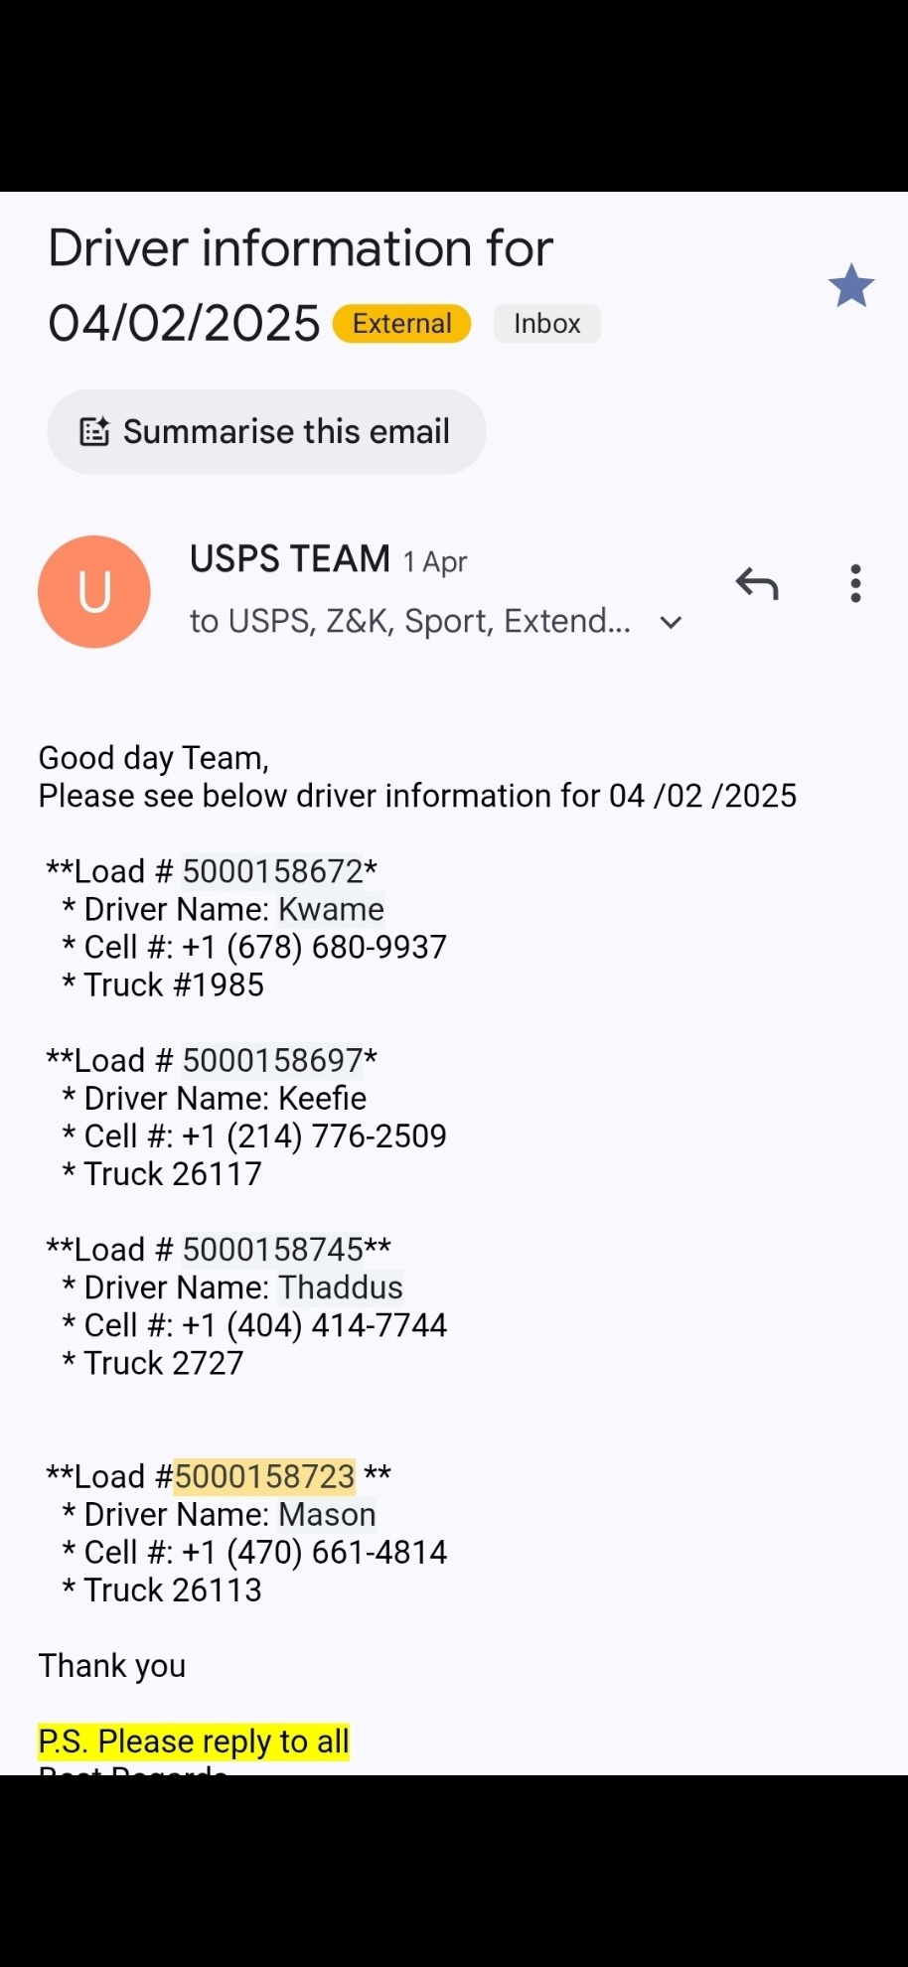

# 2. Dispatch Confirmation

Objective:  
To confirm that each dispatched driver has received and acknowledged their assigned load details, preventing confusion or missed assignments.

Procedure:  
After dispatching a load to a driver, the Traffic Department must:

1. Confirm that the driver has received the dispatch message via the dispatch system or SMS.  
2. Follow up via text or call if there is no response within 15 minutes.  
3. Verify that the driver understands the pickup location, pickup time, and any special instructions.

Best Practices:  
- Log the confirmation time in the dispatch system.  
- If the driver is unclear or has questions, clarify immediately and document the resolution.

Why It Matters:  
Load dispatch confirmation prevents missed pickups and late arrivals. It also ensures that drivers are not confused about their assignments, particularly when multiple loads are dispatched in close succession.

# 3. ETA to Shipper

Objective:  
To ensure that drivers arrive at shippers on time and that any delays are communicated early, minimizing detention and improving operational efficiency.

Procedure:  
1. One hour and thirty minutes (1:30) before the scheduled pickup time, send a text to the driver asking: “What’s your ETA?”  
2. Monitor for a response:  
 - If the driver replies promptly, log the ETA into the system.  
 - If there is no reply within 15 minutes, attempt a follow-up text.  
3. If there is still no response, call the driver exactly one hour before the scheduled pickup.

Contingencies:  
- If the driver is running late, gather details on the cause of the delay and expected arrival time.  
- Notify the broker immediately if the delay will impact the pickup time.

Value of This Process:  
This proactive check-in helps prevent last-minute surprises at the shipper. It allows the broker and shipper to make any necessary adjustments and shows a high level of operational control.

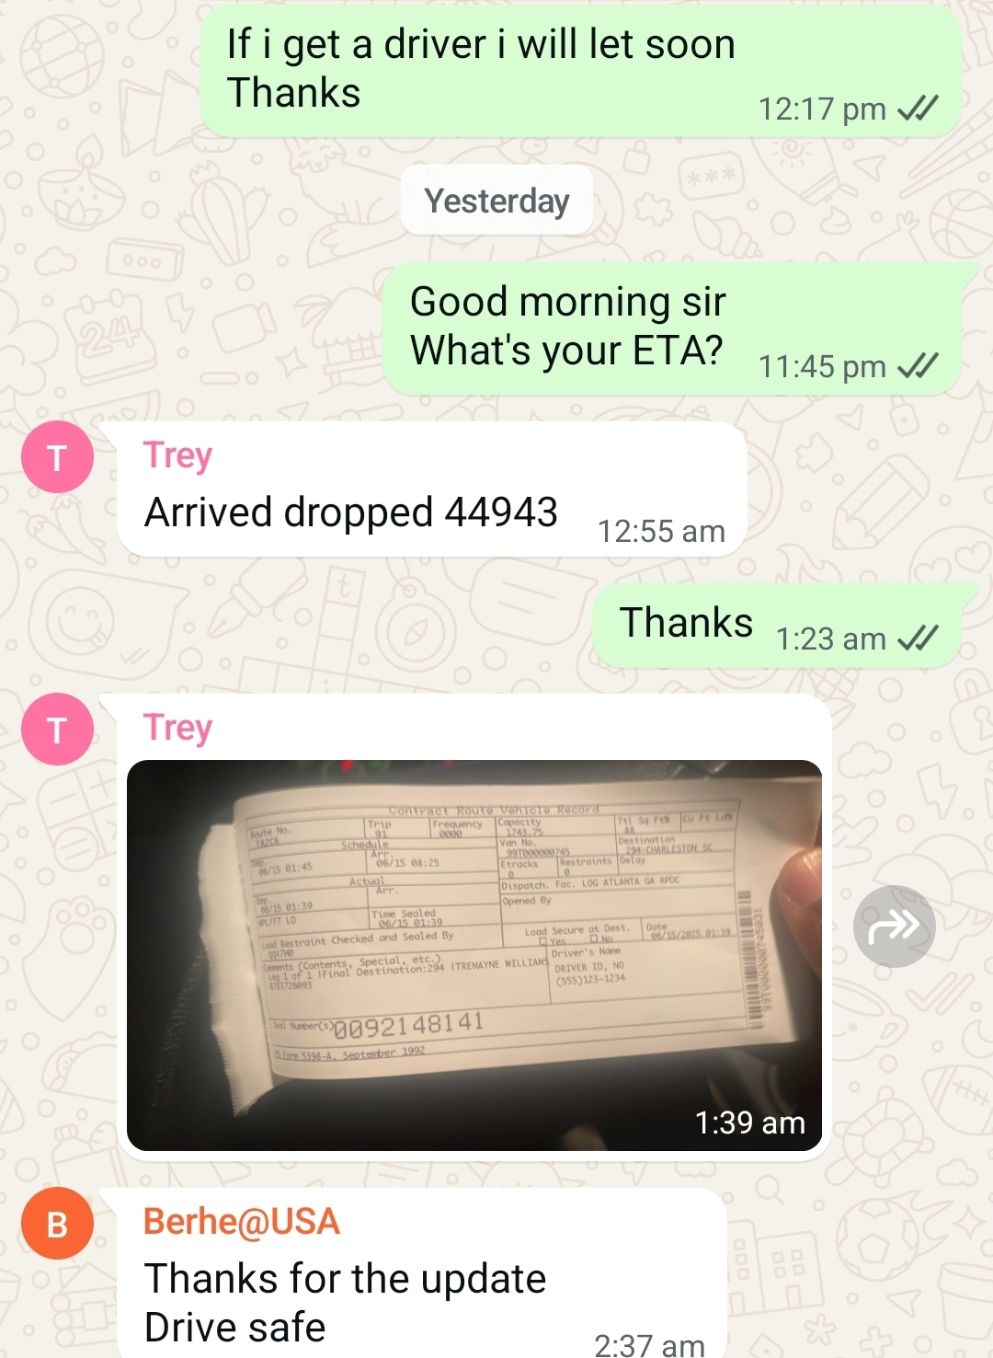

# 4. Activity Updates from Driver

Objective:  
To maintain visibility of the driver's location and status throughout the transportation process, allowing the Traffic Department to provide real-time updates to brokers and customers.

Procedure:  
Drivers must send status updates at key milestones. These updates ensure transparency and help track progress accurately. The required update points are:

1. At Shipper  
2. Arrived  
3. Checked In  
4. Departed  
5. At Receiver

Communication Guidelines:  
- Drivers should send updates via text or the fleet management app.  
- If a driver does not send updates at the expected times, the Traffic Department must initiate contact to collect the information manually.  
- All updates should be logged in the central dispatch system in real time.

Purpose:  
These checkpoints help keep the entire supply chain informed. Timely updates prevent customer complaints, enable quick resolution of issues, and support accurate on-time performance tracking.

# 5. BOL Before Departure from Shipper

Objective:  
To obtain a copy of the Bill of Lading (BOL) from the driver before they leave the shipper, ensuring that all freight is accounted for and properly documented.

Procedure:  
Once the driver notifies them that they are loaded, the dispatcher must immediately request the BOL via text or call. The following steps should be followed:

1. Ask the driver to take a clear photo of the BOL.  
2. Instruct the driver to send the photo via text or upload it to the dispatch platform.  
3. Review the document to ensure:  
 - The load number is correct.  
 - The pickup and delivery addresses match the dispatch sheet.  
 - There are no signs of damage or discrepancies noted by the shipper.

Follow-Up:  
If any discrepancies are found, contact the driver immediately to clarify and correct before they depart.

Why This Matters:  
The BOL is the legal document proving what was picked up and in what condition. Receiving it before the truck departs allows us to detect problems early, verify load accuracy, and provide immediate documentation to the broker.

# 6. Broker Updates

Objective:  
To keep the broker fully informed about the status of the load, supporting smooth communication and accountability throughout the transportation process.

Required Information to Send:  
- Driver name  
- Load number  
- Picture of the BOL  
- Check-in and check-out times at the shipper

Procedure:  
1. Immediately after departure from the shipper, compile all required details.  
2. Send a concise update via email or broker portal, using a format that clearly presents the information.  
3. If the broker has a preferred format or platform, adhere to their requirements.

Example Email Template:  
Subject: Load #12345 – Pickup Update   
Driver: John Smith   
Truck #: 678   
BOL Attached   
Check-in: 08:45 AM   
Check-out: 10:10 AM

Why This Step Is Critical:  
Timely and professional broker updates reduce the need for follow-up calls or emails, increase trust, and help build long-term relationships with logistics partners.

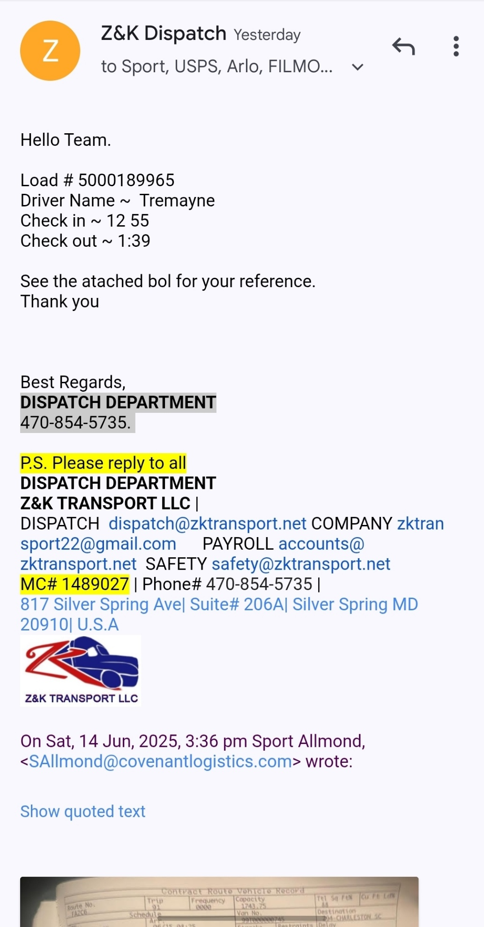

# 7. Tracking and Follow-up

Objective:  
To monitor the driver and load status until final delivery, proactively addressing delays, breakdowns, or detours.

Procedure:  
1. Use GPS tracking tools or direct communication to monitor the driver’s progress throughout the journey.  
2. Send regular check-ins if the trip is over eight hours or crosses state lines.  
3. Promptly follow up if the driver’s location deviates from the expected route or if communication lapses for more than two hours.  
4. Maintain a tracking log with:  
 - Last known location  
 - Driver communication times  
 - Any incidents or deviations

Escalation:  
If the driver goes offline or unresponsive for more than three hours:  
- Attempt phone contact immediately.  
- Escalate to management or safety team if no response.  
- Notify broker if the delivery timeline is at risk.

Benefits:  
Continuous tracking improves reliability and ensures rapid response to problems. It enhances the broker’s confidence and helps maintain delivery commitments.

# 8. Driver Breakdown

Objective:  
To ensure immediate support for drivers experiencing mechanical breakdowns and to keep brokers informed of any resulting delays.

Procedure:  
1. Driver Notification:  
 When a driver notifies the Traffic Department of a breakdown, gather the following details:  
 - Exact location (GPS or nearest city/intersection)  
 - Description of the issue  
 - Whether the truck is loaded or empty  
 - Estimated time the driver can wait before further assistance is needed

2. Maintenance Contact:  
 Contact Hareya Transportation’s maintenance department or approved roadside assistance provider to dispatch help.

3. Broker Communication:  
 Notify the broker with:  
 - Load number  
 - Breakdown location and time  
 - Driver status  
 - Any preliminary ETA changes  
 - Steps being taken to resolve the issue

4. Follow-Up:  
 Maintain ongoing communication with the driver and broker until the issue is resolved. Update ETAs as necessary.

Documentation:  
Log the incident in the dispatch system, noting:  
- Time of breakdown report  
- Assistance requested  
- Resolution time  
- Impact on delivery

Why This Matters:  
Transparent communication during a breakdown prevents misunderstandings, allows brokers to inform receivers, and reinforces Hareya’s commitment to problem-solving and accountability.

# 9. Driver Traffic Delay Updates

Objective:  
To monitor and report traffic-related delays quickly and efficiently, ensuring all stakeholders are informed and expectations are managed.

Procedure:  
1. Driver Responsibility:  
 Drivers must notify the Traffic Department if they encounter significant traffic delays, especially those impacting scheduled pickup or delivery windows.

2. Required Information:  
 - Location of the delay  
 - Cause of delay (e.g., accident, construction, weather)  
 - Duration or estimated delay time  
 - Photo evidence, if available (e.g., screenshot of GPS app showing traffic)

3. Broker Notification:  
 - Immediately notify the broker via email or portal update.  
 - Provide all relevant information, including screenshots or photos, if applicable.  
 - Update ETA based on driver input and mapping tools.

Template for Broker Update:  
Subject: Load #45678 – Traffic Delay Notice   
Driver: Maria Lopez   
Location: I-70 W, 5 miles east of Kansas City   
Cause: Multi-vehicle accident   
Estimated Delay: 1 hour   
Screenshot attached.

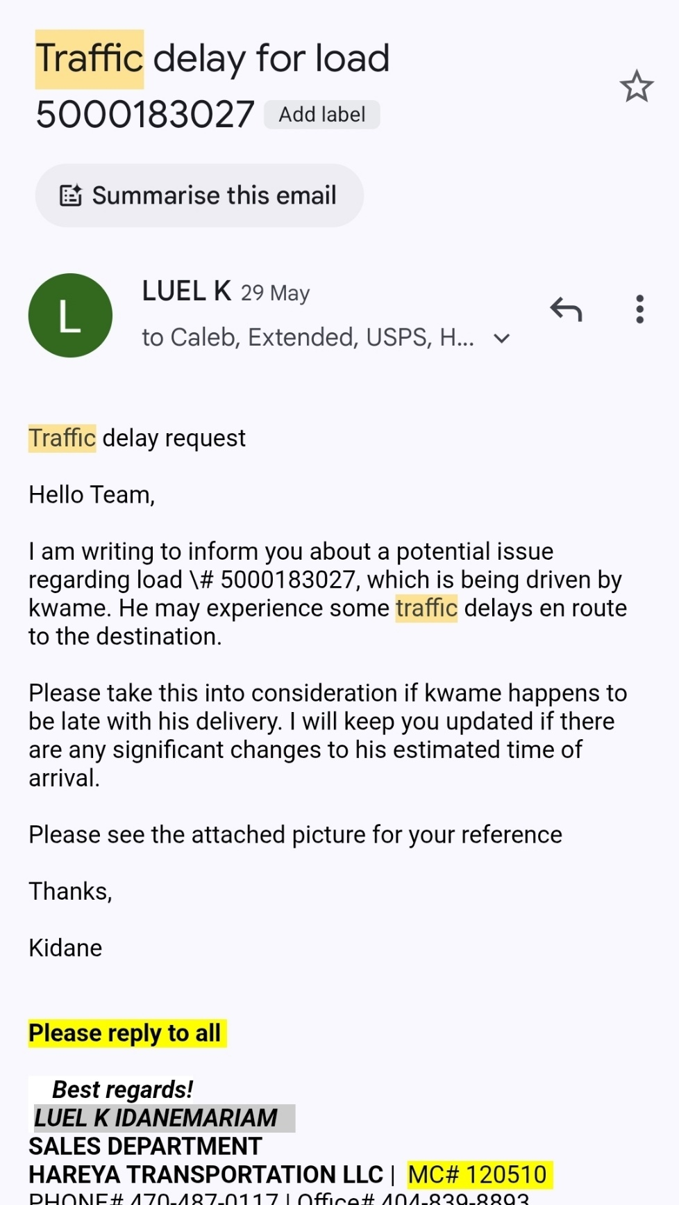Importance:  
Early notice allows brokers and consignees to adjust schedules. Documentation helps avoid penalty disputes and maintains professional credibility.

# 10. Proof of Delivery (POD)

Objective:  
To collect final delivery confirmation and supporting documentation from the driver to close out the load file and verify successful delivery.

Procedure:  
1. Once the driver has completed delivery, immediately request the POD.  
2. Instruct the driver to:  
 - Take a clear photo or scan of the signed POD  
 - Ensure receiver's signature, date, and time are visible  
 - Send it via text, email, or upload to the dispatch system

3. Confirm receipt of the POD and review for:  
 - Correct load number  
 - Receiver’s signature  
 - No reported damages unless noted

Escalation:  
If the driver forgets or delays sending the POD, follow up at 30-minute intervals until received. Escalate to the driver supervisor after 1 hour of non-response.

Importance of the POD:  
This is the final and most crucial document for load verification. It is often required for invoicing and broker proof. Without it, payment can be delayed, and disputes may arise.

# 11. Delivery Confirmation to Broker

Objective:  
To finalize communication with the broker by providing complete and accurate delivery details, including supporting documents.

Procedure:  
1. Once POD is received and verified, prepare a final update for the broker including:  
 - Load number  
 - Driver name  
 - Delivery date and time  
 - POD image attachment  
 - Any final notes (e.g., delivery delayed by 30 mins due to traffic)

2. Use the broker’s preferred communication channel (email or portal).  
3. Maintain a professional, concise format. Double-check that all attachments are clear and complete.

Example Email:  
Subject: Load #78901 – Delivered   
Delivered on: 04/30/25 at 2:45 PM   
Driver: Kevin Reid   
POD attached   
Notes: No issues reported. On-time delivery.

Why This Matters:  
Closing the loop with clear delivery confirmation ensures quick closure, supports fast billing, and reinforces Hareya’s reliability and professionalism.

# PART 3

# Fleet One Factoring: A Guide by HAREYA Transportation LLC

# Chapter 1: Introduction to Fleet One Factoring

**What Is Factoring?**

Factoring is a financial service that allows trucking companies to receive immediate payment for completed loads by selling their freight invoices to a third party—known as a factoring company. Instead of waiting 30, 45, or even 60 days for brokers to pay, companies like HAREYA receive funds within 24 hours.

At its core, factoring is about cash flow. Once a delivery is made and the proper paperwork is submitted, Fleet One pays HAREYA a significant portion of the invoice amount up front. When the broker pays Fleet One later, the remainder—minus a small fee—is settled.

**Key Benefits**:

Fast access to working capital.

Reduced Administrative Burden

Improved financial stability for daily operations.

# Why HAREYA Uses Fleet One

At HAREYA Transportation LLC, our drivers and dispatch team rely on consistent, fast, and transparent payment systems. After evaluating several factoring companies, we partnered with Fleet One for its excellent reputation, dedicated client support, and clear processes.

**Fleet One allows us to**:

Get paid the next business day after delivery

Simplify document management through their digital portal

Avoid cash flow delays that can slow down operations

Fleet One Is…

**Trusted**: Used by thousands of carriers nationwide

**Fast**: 24–48-hour payment turnaround

**Integrated**: Works seamlessly with our dispatch and billing teams

Quote Box: “Fleet One gives us the confidence to move loads every day without worrying about when we’ll get paid.”

—Operations Manager, HAREYA

# Chapter 2: Load Confirmation Retrieval

Our dispatch team begins by pulling the Rate Confirmation from the calendar. This document includes load number, pickup and delivery addresses, broker information, and payment rate. It is essential to check that all load details are correct before continuing.

At HAREYA, there are three main ways to access Load Confirmations:

1. **Email**

Dispatch sends the Rate Con as a PDF.

Check your HAREYA email or dispatcher correspondence.

2. **TMS System (Transportation Management Software)**

All accepted loads are uploaded here.

Log in, go to your load board, and download the Rate Con.

3. **Broker Portals (in some cases)**

Some brokers provide Rate Cons through their own systems.

Only use this if instructed by dispatch.

Important Note:

Never begin factoring until the finalized Rate Confirmation has been reviewed for accuracy. Checklist Sidebar:

Make Sure Your Load Confirmation Includes:

Broker name and contact

Load number

Rate amount

Pickup and delivery details

Any special instructions

# How to Verify Load Details

Once you retrieve the Load Confirmation, take a moment to review the key load details. Mistakes caught early prevent billing delays later.

Verify the Following Fields:

**Broker Name** – Must match what’s submitted to Fleet One

**Load Number** – Critical for invoice and file naming

**Agreed Rate** – Matches what you expect to be paid

**Pickup & Delivery Addresses** – Confirm locations and appointment times Accessorial Charges – Detention, layover, or other extra pay should be listed Policy Reminder:

If anything looks incorrect, contact your dispatcher before moving forward. HAREYA requires that all load details are confirmed before paperwork submission.

Quick Tip Box:

Double-check time zones and appointment windows to avoid delays at pickup or drop.

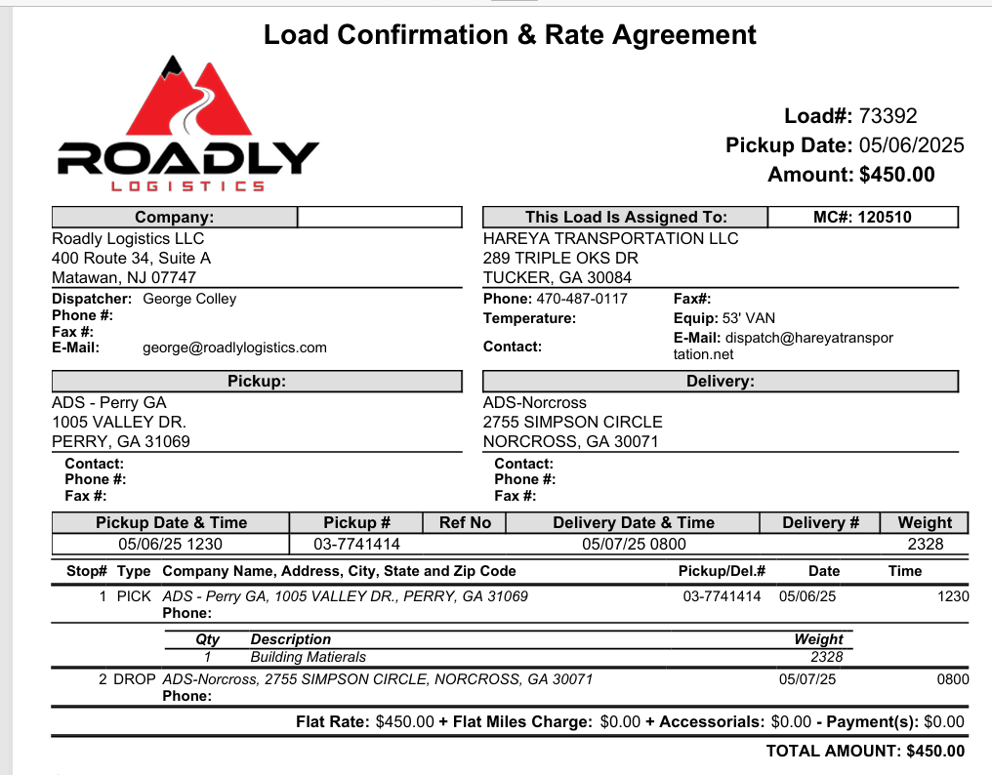

# Chapter 3: Broker Credit Check

Before hauling any load, HAREYA requires that every broker be verified using Fleet One’s Credit Lookup Tool. This tool helps determine whether a broker is financially reliable and eligible for factoring.

**Why It Matters**:

Factoring, companies only purchase invoices from brokers they trust to pay. If a broker has a history of delayed or denied payments, your load might be rejected—or worse, unpaid.

How to Use the Tool:

1. Log in to your Fleet One (or WEX) portal.
2. Go to the Credit Check section.
3. Enter the broker’s MC#, DOT#, or name.
4. Review the status indicator and credit details.

Example Search Fields:

MC Number

DOT Number

Legal Company Name

# Understanding Status Colors & Company Policy

Fleet One uses a simple color-coded system to rate brokers. Here’s what each color means, and how HAREYA responds to them:

|  |  |  |
| --- | --- | --- |
| **Color** | **Meaning** | **HAREYA Policy** |
| Green | Excellent Credit | Approved for factoring. Proceed with load. |
| Yellow | Limited Credit | Use caution. Dispatch must approve before proceeding. |
| Red | High Risk/Denied | Not approved. Do not accept the load without management approval |

Important Note:

If a broker shows as Yellow or Red, inform dispatch immediately. Never rely on verbal promises—HAREYA only factors load with green-rated brokers unless management signs off.

Quick Tip Box:

Always save a screenshot of the broker’s credit result for documentation, especially if the load becomes disputed.

# Chapter 4: POD Collection and Verification What Makes a Valid POD

A POD (Proof of Delivery) is the document signed by the receiver confirming that the shipment was delivered. This is a required document for all factoring submissions—it proves the job was completed.

Without a valid POD, Fleet One will reject the invoice, and payment will be delayed.

To Be Considered Valid, a POD Must Include:

Receiver’s signature and printed name

Date of delivery

Complete load details (matching the Load Confirmation)

Clear and legible print—no smudges, no dark scans Examples of Acceptable PODs:

Bill of Lading (BOL) with final signature Electronic PODs, if clearly marked and official Policy Reminder:

Always scan or take a photo of the signed POD immediately after delivery. Upload it before leaving the receiver’s dock if possible.

Quick Tip Box:

Keep blank BOLs in your truck just in case the shipper or receiver doesn’t provide one.

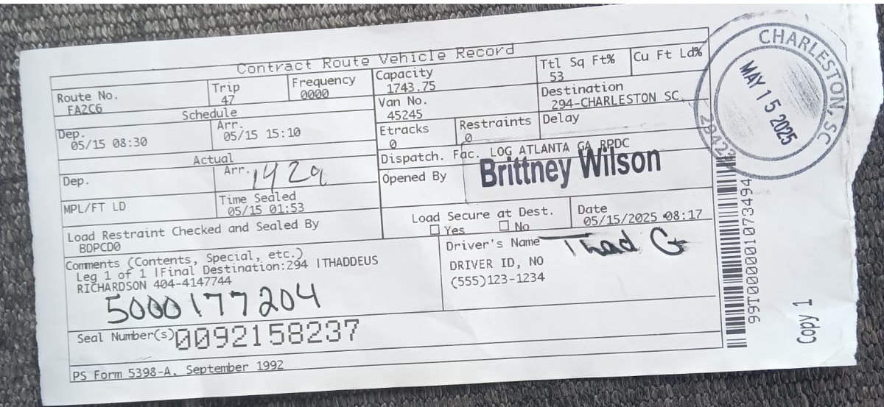

# Examples of Unacceptable PODs

Even a minor issue can cause Fleet One to reject your file. Here are the most common reasons PODs are rejected:

|  |  |
| --- | --- |
| Problem | Why It’s a Problem |
| Blurry or dark images | Text and signature unread |
| Missing signature or date | No confirmation of deliver |
| Handwritten notes blocking Data | Critical info may be covered unclear |
| Wrong or mismatched Paperwork | Doesn’t match Load Confirmation or Invoice |
| Cropped or cut-off scans | Key parts of document not visible |

**How to Avoid Rejection**:

Always review your scan before submitting.

Use a mobile scanning app like **Cam Scanner** or **Genius Scan** for clear, full-page images.

Compare the POD to the Load Confirmation to ensure accuracy.

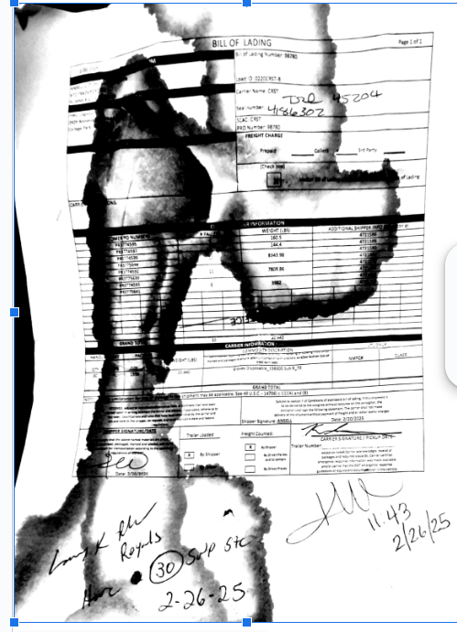

# Chapter 5: Building a Billing File Step-by-Step: Building the Billing File

To get paid through Fleet One, you must submit a complete and organized billing file. Each file includes the core documents that prove the job was accepted, completed, and signed off.

Here’s a step-by-step guide to building your file the HAREYA way:

1. Retrieve the Load Confirmation

Finalized version only. Must match what dispatch approved.

1. Collect the Signed POD

Must be legible, with signature and delivery date.

1. Create the Invoice

Use the Fleet One invoice template provided by HAREYA.

Fill in all required fields clearly and correctly.

1. Double-Check for Accuracy

Load #, Invoice #, and Broker name must match across all documents.

1. Save All Documents

Use clear file names like:

123456_Invoice.pdf

123456_POD.pdf

123456_RateCon.pdf

1. Combine or Submit Files as Directed

Submit as individual attachments or one merged file, based on Fleet One instructions.

Tip Box:

**“Organized files = faster approvals. Disorganized files = delays or rejections.”**

# Required Fields Explained

When completing your invoice using the Fleet One template, be sure to fill in the following required fields:

|  |  |
| --- | --- |
| **Field** | **Explanation** |
| Invoice Number | Unique ID for the invoice (format: HAREYA-0001) |
| Load Number | Must match the Load Confirmation exactly |
| Broker Name | Legal name of the broker (doublecheck spelling!) |
| Pickup & Delivery Dates | Match what’s on the POD and Load Con |
| Rate/Total Due | Agreed rate per the Load Confirmation |
| Payment Terms | “Net 30,” “Quick Pay,” etc. – depends on broker terms |
| Remit To Address | HAREYA’s payment address (prefilled in template) |

Using the Template:

HAREYA provides a standard invoice template that already includes company details. Use “Save As” for each load, then rename with the correct invoice number.

Quick Tip Box:

“If in doubt, match your invoice line-by-line with the Load Confirmation. Consistency is key.”

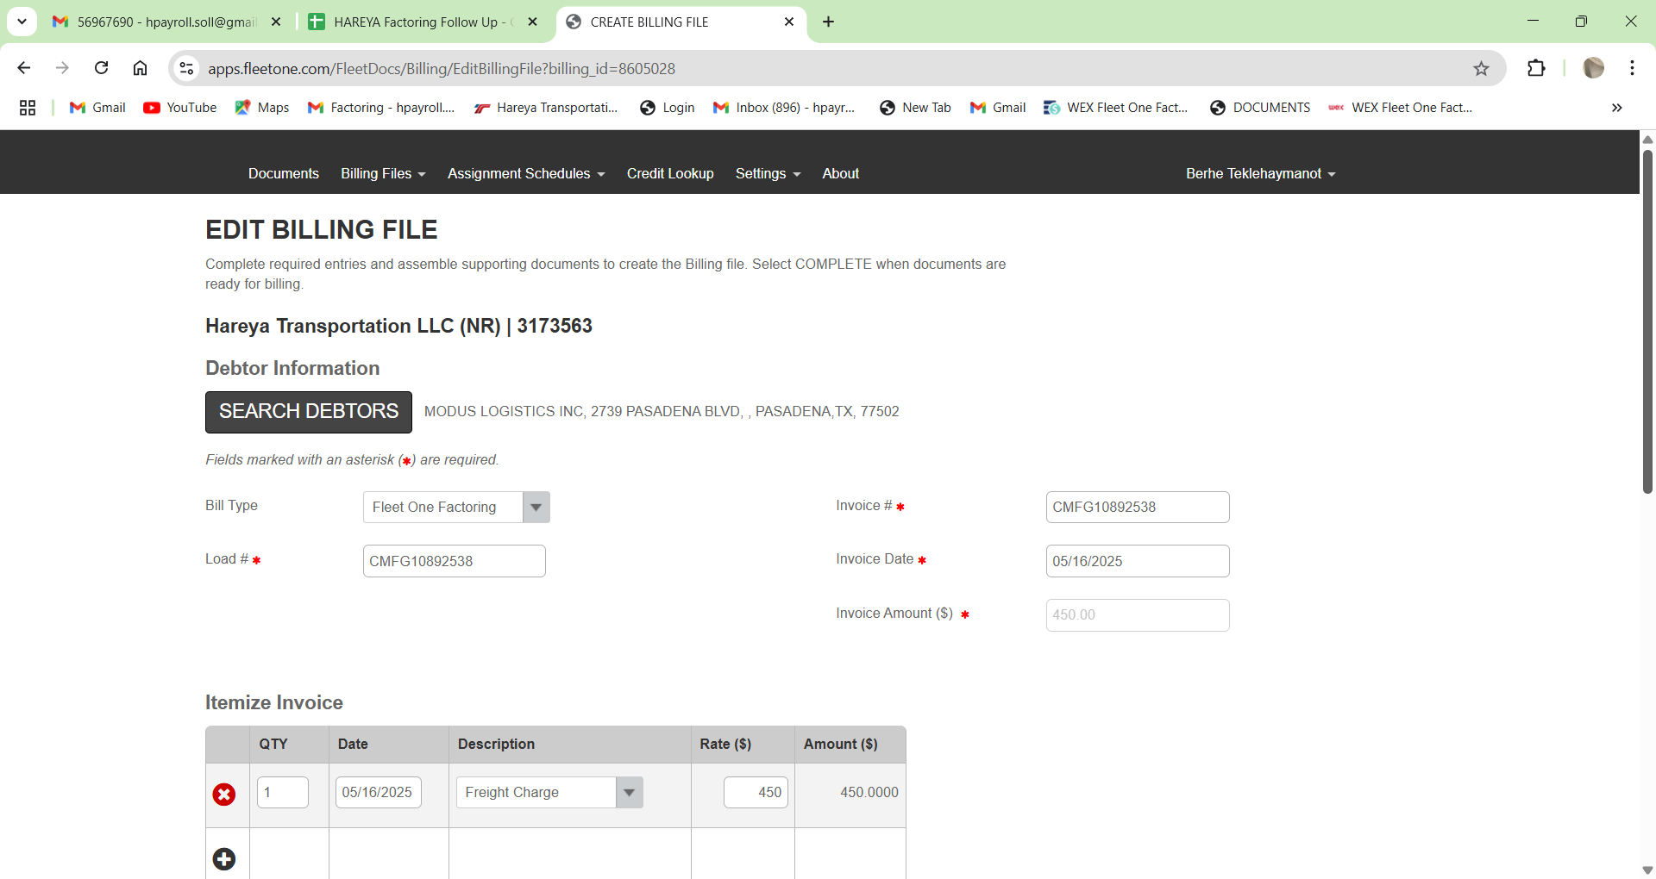

# Chapter 6: Uploading Supporting Documents Best Practices for Document Uploads

Once you’ve built your billing file, the next step is to upload the documents to Fleet One’s factoring portal. Uploading documents properly helps avoid delays and ensures faster processing.

Best Practices for Uploading:

* File Clarity

All documents must be clear and legible. No blurs, shadows, or cuts.

* Use Correct File Names Example:

HAREYA_Inv1234.pdf,

Load1234_POD.pdf,l

Load1234_RateCon.pdf

* Consistent File Format

Use PDF format whenever possible.

If using images, ensure they’re in JPEG or PNG with high resolution.

Organize Like This:

1. **Invoice** – Clearly labeled
2. **POD** – Signed and complete

# Load Confirmation (Rate Con) – Final version

4. **Additional Docs (if any)** – Lumper receipts, accessorial approvals, etc.

Tip Box:

“Label files with the load number and document type to avoid confusion during processing.”

# Common Mistakes to Avoid

Mistakes during upload can delay your payment by several days. Here are the most common upload errors and how to avoid them:

|  |  |
| --- | --- |
| Mistake | Why It’s a Problem |
| Uploading dark or cropped images | Key information is unreadable |
| Submitting the wrong Rate Con | Mismatch in load info causes rejection |
| Combining unrelated loads in one file | Creates confusion and slows down approvals |
| Leaving out the POD or Invoice | File is considered incomplete |
| Wrong file names or formats | Makes it harder for Fleet one to process efficiently |

Avoid Rejection By:

Reviewing all files before uploading

Uploading documents as **separate attachments**, unless instructed, Following the HAREYA checklist for each load

Quick Tip Box:

“After uploading, always double-check the file status and ensure everything shows as “Submitted.””

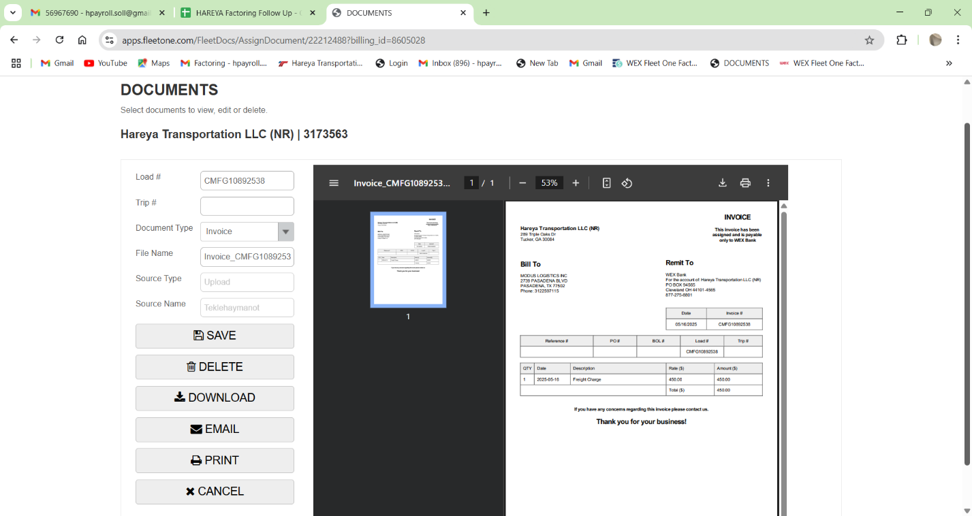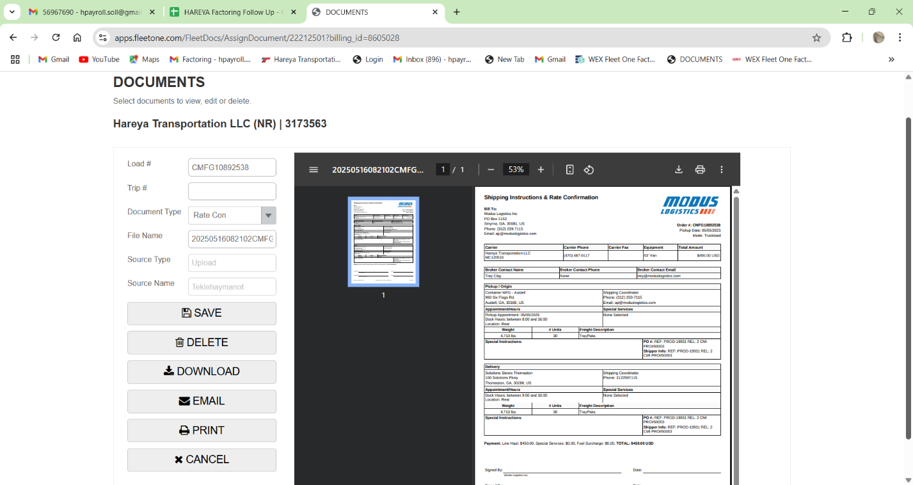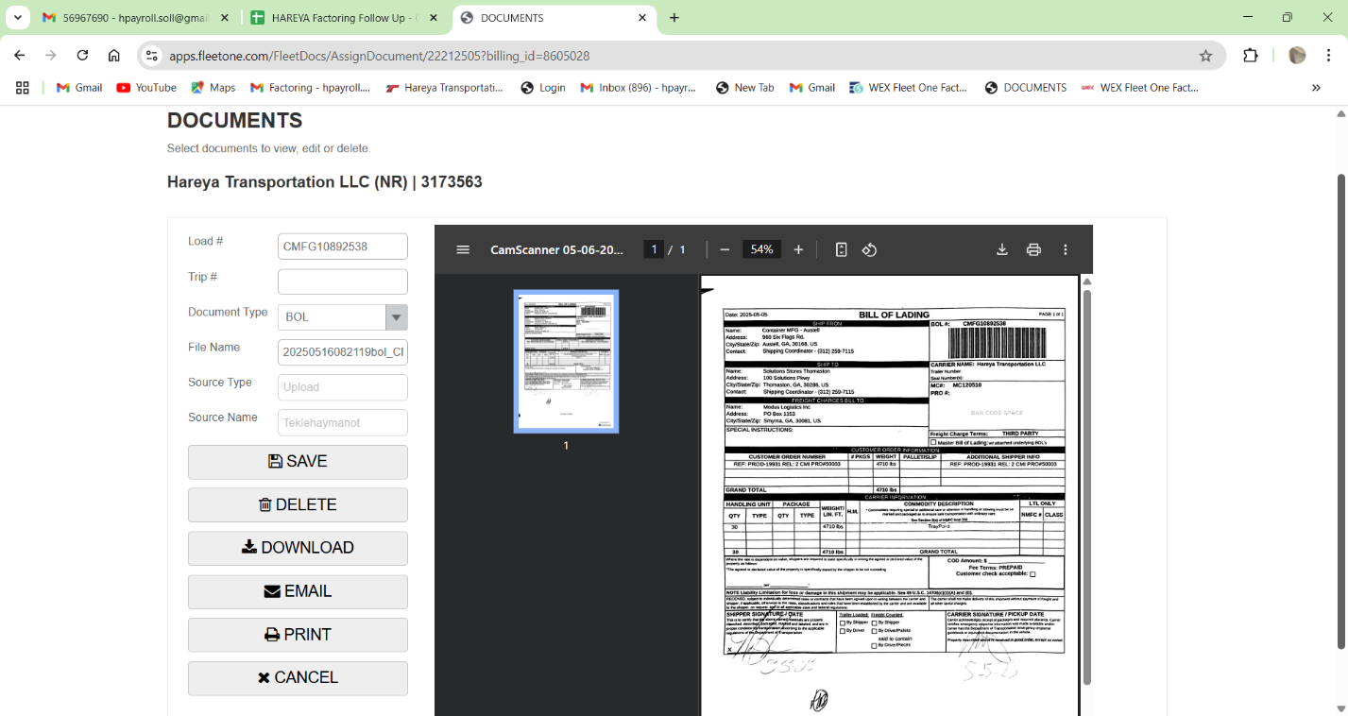

# Chapter 7: Completing the Process Submitting the Billing File

After you’ve prepared and uploaded all necessary documents, the final step is to submit your complete billing file to Fleet One. This process triggers the factoring process and begins the timeline for payment.

Steps to Submit Your Billing File:

1. Log into Fleet One Portal

Ensure you’re using the correct login credentials for your HAREYA account.

1. Go to the “Billing” Section

Find the “Submit Invoice” option.

1. Select the Correct Load

Choose the load you’re submitting for factoring. Ensure that the invoice and attached documents match the load number.

1. Verify All Documents Are Attached

Double-check that the invoice, POD, and Rate Con (if applicable) are all included.

1. Click “Submit”

Once confirmed, click the “Submit” button. You should receive a confirmation email from Fleet One that your file has been received.

# Tracking Progress in Fleet One

After submission, you can track the progress of your invoice through the Fleet One portal. This tracking feature allows you to stay updated on the status of your payment.

How to Track Your File:

1. Log into Fleet One Portal

Navigate to the “Billing” section.

1. View Your Pending Files

All submitted files will be listed under the “Pending” tab.

Check each load to see if there are any issues or comments from Fleet One.

1. Payment Status Updates

Once your file is processed, Fleet One will change the status to “Approved for Payment” or “Rejected.”

If rejected, the system will provide feedback for you to correct.

Payment Timeline:

Approved files will typically be processed for payment within 1–2 business days.

Payments will be deposited into your designated bank account.

Policy Reminder:

If your file is rejected, it’s crucial to fix the issue and resubmit quickly to avoid payment delays.

Quick Tip Box:

“**Always monitor your file status to ensure payment isn’t delayed. If you notice anything unusual, reach out to Fleet One support immediately**.”

# Chapter 8: Troubleshooting & FAQs

**What Happens if a File Is Rejected?**

If Fleet One rejects your file, don’t panic—it’s a common part of the process. Rejections typically happen due to missing or incorrect information. However, they can be fixed quickly if you follow the right steps.

**Common Reasons for Rejection:**

1. Missing or Incorrect POD

Ensure the POD is signed, dated, and legible.

1. Incorrect Broker Name/Load Number

Double-check the load number and broker information in your billing file.

1. Unclear or Invalid Invoice Details

Ensure the invoice matches the Load Confirmation exactly, with no discrepancies in the payment terms or agreed rate.

**How to Resolve a Rejected File:**

1. Review of the Rejection Notice

Fleet One will provide specific feedback about what’s wrong.

1. Fix the Issue

Address the issue by uploading the corrected document (e.g., clearer POD, corrected rate on invoice).

1. Resubmit

Once fixed, submit the corrected file again through the Fleet One portal.

Quick Tip Box:

“**Always check your rejection notice carefully to avoid resubmitting with the**

# How to Contact Fleet One Support

If you encounter any issues with your Fleet One submission or have questions about your account, Fleet One support is here to help. Their team is available to assist with everything from invoice issues to system navigation.

**How to Contact Support:**

Phone Support: Call the Fleet One support team at 1-800-555-1234 (available Monday– Friday, 8 AM–5 PM EST).

Email Support: Reach out via email at support@fleetone.com for non-urgent inquiries.

Live Chat: Available on the Fleet One portal, Monday–Friday, 9 AM–4 PM EST.

**Before You Contact Support:**

1. Prepare Your Account Information

Have your Fleet One login detail and load numbers ready.

1. Know Your Issue

Clearly describe the issue (e.g., rejected file, payment delay).

1. Be Ready to Provide Documentation

If you’re dealing with a rejected file or missing payment, have your documents (invoice, POD, etc.) ready to share.

Quote Box:

“**Fleet One’s support team has been incredibly helpful in resolving any issues we’ve faced with the submission process.”** —**Driver, HAREYA Transportation LLC**

# FAQ Section

Here are some common questions we’ve received from HAREYA drivers and staff, along with answers to help you navigate the Fleet One factoring process:

1. What if my broker’s credit status is red?

If the broker has a red credit status, do not accept the load without management approval. Contact dispatch to discuss options.

1. How do I know when my payment has been processed?

You will receive a payment notification once your invoice has been approved. Payments typically arrive within 24–48 hours of approval.

1. Can I submit multiple invoices to the same broker at once?

Yes, you can submit multiple invoices to a broker, but make sure each load has its own billing file and documentation. Do not combine unrelated loads into one submission.

1. What if my POD was signed in a different location than where the load was dropped?

If the POD shows the correct delivery address and is signed by the receiver, it’s acceptable. If there’s confusion, check with dispatch for clarification.

**Appendix**

## Glossary of Terms

Key Terms You Should Know

Understanding the terminology used in the factoring process is crucial for smooth operations. Here’s a helpful glossary to guide you through the most common terms you’ll encounter.

|  |  |
| --- | --- |
| **Term** | **Definition** |
| Factoring | The process of selling your invoices to a factoring company like Fleet One in exchange for immediate payment. |
| Broker | A third-party entity that arranges the transportation of freight between shippers and carriers. |
| POD (Proof of Delivery) | A signed document proving that the load was successfully delivered to the consignee. |
| Invoice | A document that outlines the amount due for the transportation services provided, including load details and payment terms. |
| Load Confirmation | A document from the broker or shipper detailing the load’s terms and conditions, including rate, pickup, and delivery info. |
| Rate Con (Rate Confirmation) | A type of Load Confirmation detailing the agreed payment rate and other terms of the load. |
| Fleet One Portal | The online system used to upload and track invoices, PODs, and other related documents. |
| Quick Pay | A payment option where the factoring company releases funds faster than the standard payment terms, often for a fee. |
| Net 30 | A common payment term that indicates the invoice is due 30 days after the delivery date or invoice date. |
| Rejection Notice | A message from Fleet One indicates that a file or document was not accepted due to an error or missing information. |
| Submission Status | The current stage of a submitted billing file such as Pending, Approved, or Rejected. |
| Lumper | A fee paid to a third party for loading or unloading services, often billed separately. |

Quick Tip Box:

**“Refer to this glossary whenever you encounter unfamiliar terms. It will save you time and reduce confusion.”**

## Example Documents: Invoice

Here’s an example of a properly completed invoice that you will submit to Fleet One. Use this as a reference to ensure your invoices are correctly formatted.

Example Invoice Structure:

HAREYA Transportation LLC

Invoice #: 1001

Date: 05/01/2025

Broker: XYZ Logistics

Load #: 456789

Rate: $1,000.00

Payment Terms: Net 30

Remit To: HAREYA Payment Processing, 1234 HAREYA Blvd, City, State, ZIP

Line Items:

Pickup Location: 123 Main St, City, State

Delivery Location: 456 Delivery Ave, City, State

Load Description: Full truckload, dry goods

Total Due: $1,000.00

## Example Documents: POD & Rate Confirmation

Here are examples of the Proof of Delivery (POD) and Rate Confirmation (Rate Con) documents that you will submit with your billing files.

Sample POD (Proof of Delivery):

Date of Delivery: 05/01/2025

Receiver: John Doe, XYZ Warehouse

Delivery Address: 456 Delivery Ave, City, State

Signature: [Receiver’s Signature]

Notes: Load delivered without incident, signed on the receiving dock.

Sample Rate Confirmation (Rate Con):

Broker: XYZ Logistics

Load Number: 456789

Rate: $1,000.00

Pickup Date: 05/01/2025

Delivery Date: 05/01/2025

Additional Details: Dry goods, no special handling required

Quick Tip Box:

## “Ensure all documents are signed and clearly legible. Submitting a complete and accurate POD is crucial for timely payment processing”

PART 4

**Invoice Submission and Payment Coordination: A Collaborative Process with HAREYA TRANSPORTATION LLC**

**Step 1: Rate Confirmation and Data Extraction**

At HAREYA TRANSPORTATION LLC, the invoice management process begins the moment a **rate confirmation** is received via email from a broker. This document serves as the contractual agreement outlining the essential details of the load, including:

* **Load number**
* **Agreed rate or amount**
* **Broker name**
* **Pickup and delivery dates**
* **Origin and destination**
* **Special instructions, if any**

Upon receiving the confirmation rate, our operations team meticulously reviews the email for accuracy. We then **extract the key load data** and enter it into our internal **invoice tracking spreadsheet**, which serves as a live record of all pending, processed, and paid invoices.

Each entry is cross-referenced with our **dispatch logs and delivery receipts**, ensuring that the data aligns with real-world movements of our trucks and drivers. This not only helps with error prevention but also creates a central source of truth accessible to both administrative and accounting staff.

To maintain structure and consistency, we use a standardized format for our spreadsheet, including columns for:

* Load #
* Broker name
* Agreed amount
* Pickup date
* Delivery date
* Invoice status (Pending, Submitted, Paid, Rejected)
* Notes (e.g., missing POD, blurry POD, advance received)

This initial data entry phase sets the foundation for the entire invoicing lifecycle, making it one of the most critical steps in our workflow.

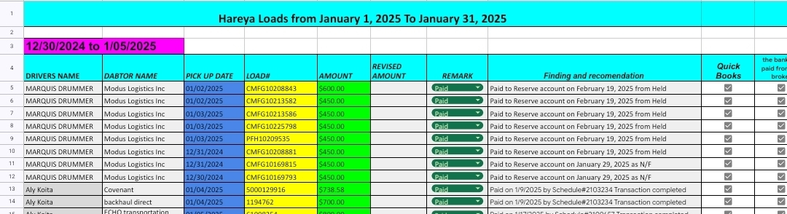

**Step 2: Weekly Invoice Submission and Payment Processing**

Every Thursday, HAREYA TRANSPORTATION LLC initiates the **invoice reconciliation and submission** process. Using our internal spreadsheet, we identify which loads are ready for billing—typically those that have been delivered and have complete documentation (proof of delivery, bills of lading, etc.).

Once we confirm that all load data is accurate and complete, we prepare the invoice packets. These packets usually include:

* A copy of the rate confirmation
* The completed invoice (with load details and charges)
* Proof of delivery (POD)
* Any additional documentation requested by the broker or required by Wex Bank

These packets are then **submitted to Wex Bank** for processing. Wex Bank typically processes advance payments—minus a **1% service fee**—every **Wednesday or Thursday** following submission.

When payments are released, Wex provides us with a **PDF payment schedule** via email, which includes:

* Schedule number
* Invoice numbers paid
* Amounts
* Date of deposit

This document is vital for matching payments to submitted invoices and updating our internal tracking systems.

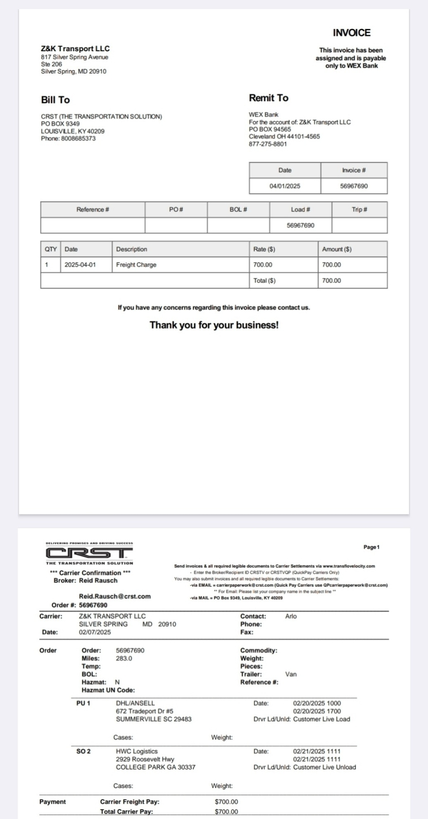

**Step 3: Handling Errors and Invoice Rejections**

Despite careful preparation, there are instances where invoices are rejected, or payments are delayed. The most common issues we encounter include:

* **Missing Proof of Delivery (POD) pages**
* **Blurry or illegible POD scans**
* **Mismatched invoice details**
* **Duplicate submissions**

When such errors occur, Wex Bank typically responds with rejection notices using phrases like:

* “Unable to process”
* “Denied”
* Or, in some cases, they simply withhold payment without explanation

Upon receiving such notice if payment is not received as expected—we initiate an **internal audit** of the affected invoice. We recheck the documents, request updated or clearer copies from drivers or dispatchers and**prepare a corrected submission**.

Corrected invoices are queued for **resubmission the following week**, ensuring no disruption to our overall billing rhythm.

**Step 4: Monitoring Factoring Communications and Chargeback Prevention**

Our department actively monitors a dedicated email inbox for all **factoring-related correspondence**. This includes updates from Wex Bank regarding invoice issues, chargebacks, and payment status. Constant vigilance allows us to:

* **React immediately to notifications**
* **Resolve POD issues proactively**
* **Prevent chargebacks before they occur**

Chargebacks can occur when Wex or the broker determines that a previously paid invoice is invalid due to documentation problems or delivery disputes. By keeping a close eye on communication and acting swiftly, HAREYA TRANSPORTATION LLC minimizes financial risks and maintains trust with financial partners.

**Step 5: Adjustments and Payment Reconciliation**

At HAREYA TRANSPORTATION LLC, **payment reconciliation** is a weekly task that ensures all submitted invoices are accounted for, especially those that experience delays or partial payments. This step is vital to:

* Track unpaid invoices
* Address discrepancies
* Ensure no revenue is lost due to oversight

When an invoice is **short-paid** or **unpaid**, we investigate by reviewing the payment schedule PDF from Wex Bank, comparing it to our records in the spreadsheet. If discrepancies exist—such as amounts that differ from the invoice total or payments that are entirely missing—we do the following:

1. **Cross-check documents:** Verify the invoice, POD, rate confirmation, and any relevant notes.
2. **Update the broker:** Notify the broker about the issue and request clarification or missing documentation.
3. **Submit corrections to Wex Bank:** Once corrected, we forward the new documentation, referring to the original invoice and schedule number.

These **adjusted invoices** are then resubmitted and monitored closely. Once payment is made, we log it and update the spreadsheet to reflect the corrected status.

This process allows us to **maintain an accurate cash flow forecast**, which is critical for budgeting, payroll, and business planning.

**Step 6: Reserve Account Management and Chargeback Resolutions**

Wex Bank maintains a **reserve account** for all clients, including HAREYA TRANSPORTATION LLC. This account serves as a buffer for future adjustments, including chargebacks and reimbursements.

When a **chargeback** occurs—often due to an error in documentation or a delivery dispute—the funds are temporarily pulled from our available payments and placed into the reserve. Once we **resolve the issue** and provide satisfactory documentation, the funds are:

* **Credited back** to our reserve
* Logged in the payment PDF under the “reversal” or “credit” section

Our team keeps **detailed records of chargebacks**, including:

* Date of occurrence
* Load and invoice number
* Reason for chargeback
* Resolution status
* Date of reimbursement (if applicable)

This information not only helps with tracking payments but also assists in identifying recurring issues that need to be addressed operationally—such as driver scanning quality or training around documentation requirements.

Our proactive approach ensures that the reserve account remains healthy and that our **overall financial risk is minimized**.

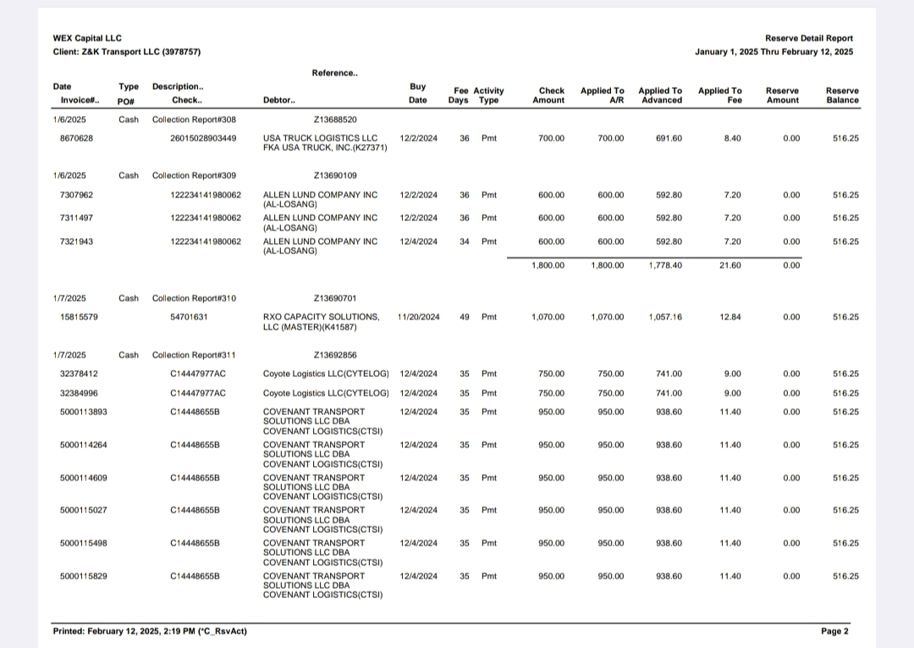

Chargeback report

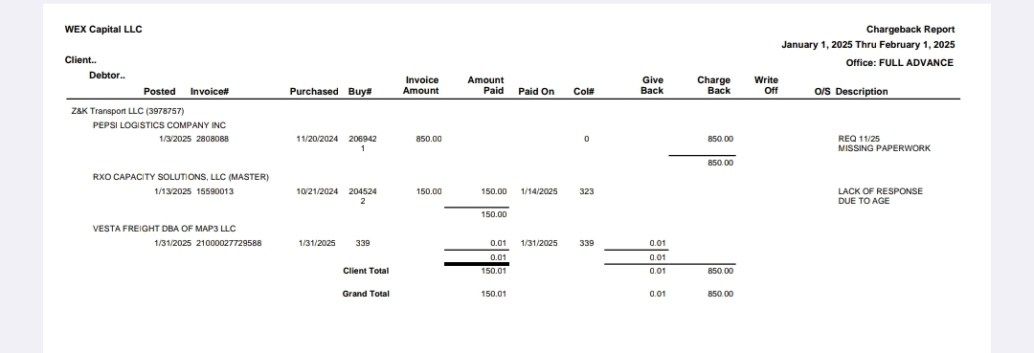

**Step 7: Using the Wex Capital Web Portal for Document Management**

The Wex Capital online portal plays a key role in our document and invoice management system. Through this portal, we can:

* **Upload invoices and documentation**
* **Download weekly payment schedules**
* **Access reserve details**
* **Review of chargeback reports**
* **Generate age reports for unpaid invoices**

The **scheduled payment PDFs** are used to update our records each week. The **ageing report** is especially helpful in identifying invoices that are more than 30, 60, or 90 days old, allowing us to prioritize collections and follow-ups.

We also use this portal to **cross-verify broker payments**, confirm schedule numbers, and download historical data during audits or tax preparation periods.

Using the Wex Capital portal allows HAREYA TRANSPORTATION LLC to **centralize** all invoice-related data and reduce the chance of human error associated with manual tracking. It also improves transparency and gives us real-time visibility of the financial health of our receivables.

**Conclusion and Recommendations**

At HAREYA TRANSPORTATION LLC, our structured invoice submission and payment coordination process is built on clarity, consistency, and collaboration. By breaking down the process into key steps—each with detailed tracking and verification—we ensure that:

* Payments are received on time
* Errors are addressed proactively
* Financial risks are minimized
* Brokers and banking partners have full trust in our process

Our recommendations for maintaining and improving this system include:

1. **Enhancing automation**: Explore automated OCR tools for invoice scanning and data entry.
2. **Improving POD quality**: Standardize driver training on capturing clear PODs.
3. **Building an internal dashboard**: Create a visual tool to track payment statuses and chargeback trends.
4. **Routine audits**: Conduct monthly invoice audits to catch patterns of error and improve documentation standards.

By continuing to refine our processes, HAREYA TRANSPORTATION LLC aims to remain a reliable and efficient partner in logistics, setting a standard for invoice management in the industry.

**(Optional Appendices)**

* **Sample Invoice Template**
* **Weekly Tracking Spreadsheet Example**
* **Email Template for Rejected Invoice Follow-up**
* **Wex Bank Payment PDF Sample**

